 |  | CL1000 |  |  |  |  |  | LAB 02
 | I |  |  |  |  |  |  | LAB 02
 | INTRODUCTION |  |  |  |  |  |  | LAB 02
 |  |  |  |  |  |  |  | MS-Word
 | TO ICT |  |  |  |  |  |  | MS-Word


NATIONAL UNIVERSITY OF COMPUTER AND EMERGING SCIENCES

Advanced Microsoft Word 2007

Topics covered in this session:

- Creating tables
- Adding table rows and columns
- Deleting table rows and columns
- Merging/splitting table rows and columns
- Changing text direction
- Table formatting, borders, and shading
- Paragraph borders/shading
- Horizontal Lines
- Inserting Headers/Footers
- Inserting Page Numbers
- Inserting Symbols
- Inserting ClipArt/Images
- Using the Picture Styles/Tools
- WordArt
- Smart Art
- Bullets and Numbering
- Adding References
- use and remove hyper linking
- use macro

Creating a New Table

- Click the Insert tab, then click the down arrow below the Table icon, highlight the number of columns and rows you wish to create. If you don’t choose enough, you can always add colums or rows later.
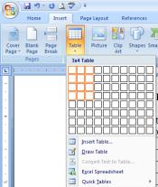

- Once you have the table created, you can begin typing information into the cells. To move from one cell to another, press Tab. To go back one cell, press Shift + Tab.

Adding/Inserting Table Rows/Columns

- To add a table row at the bottom of the table, press Tab.

- To insert a table row inside the table, highlight the row where you wish to insert a row. Right-click in the selection, click Insert and choose Insert Rows Above or Insert Rows Below.

- To insert columns in the table, highlight the column where you wish to insert a column. Right-click in the selection, click Insert and choose Insert Columns to the Left or Insert Columns to the Right.
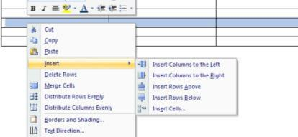
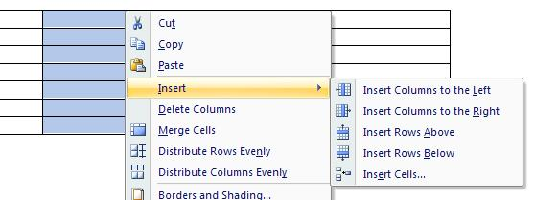
Deleting Table Rows/Columns
- To delete a table row, highlight the row you wish to delete. Right-click in the selection, click Delete Rows.

- To delete a table column, highlight the column you wish to delete. Right-click in the selection, click Delete Columns.
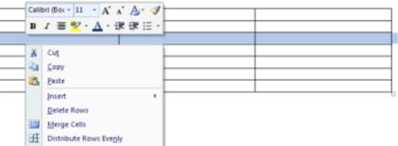
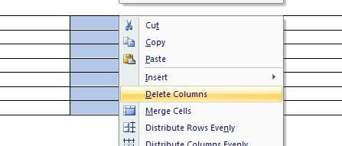

Merging/Splitting Table Rows/Columns

- To merge a group of cells in a table, highlight the cells you wish to group together. Right-click in the selection, click Merge Cells.
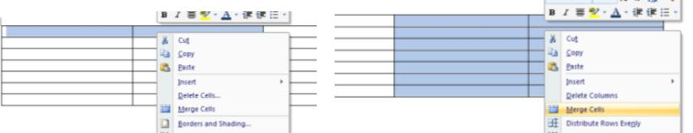

Merge Rows Merge Columns

- To split a cell in a table, right-click in the cell you wish to split, click Split Cells.
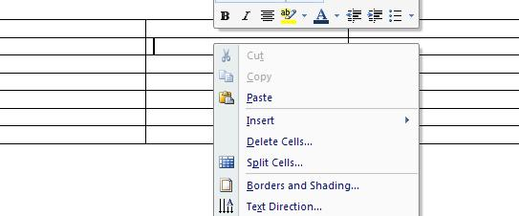

Changing Text Direction in a Table

- Right-click in the cell that contains the text you wish to change the direction for. Click Text Direction and choose the format you wish.
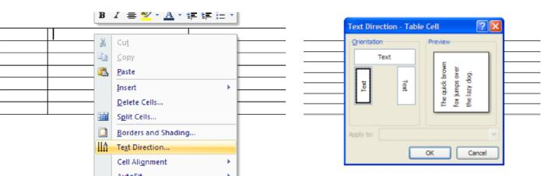

Adding Table Formats/Borders/Shading
- Highlight the table you wish to apply the format to. In the Table Tools QuickMenu, there are numerous styles already set up. To apply one of these, click the appropriate icon.
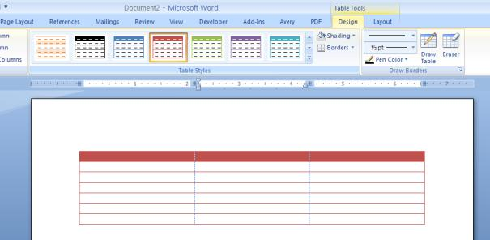

- To apply borders to cells or the entire table, click the down arrow beside the Borders icon in the Table Styles section of the Design Ribbon. Click on the type of border you want.
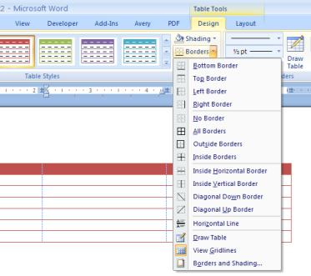

- To apply a combination of borders, click the Borders and Shading option at the bottom of the pull-down list.

- Shading can also be applied to cells: Highlight the cells you wish to apply shading to, click the down arrow beside the Shading icon in the Table Styles section of the Design Ribbon. Click on the color of your choice.
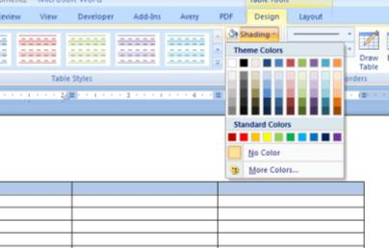

Paragraph Borders/Shading

- Highlight the paragraph you wish to put a border around. Click the down arrow to the right of the

borders icon in the Paragraph group of the Home Ribbon. Click the Borders and Shading option at the bottom of the drop-down list.
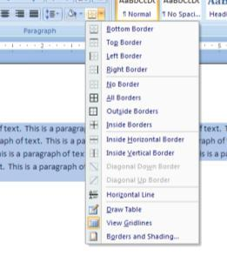

- Choose the type of border you wish to put around the paragraph/selected text, as well as the line thickness, type, color, etc. Also be sure the “Apply to” option is set to paragraph. Once options are set, click OK. HINT: If the setting doesn’t show up in the Preview box, it is NOT selected.
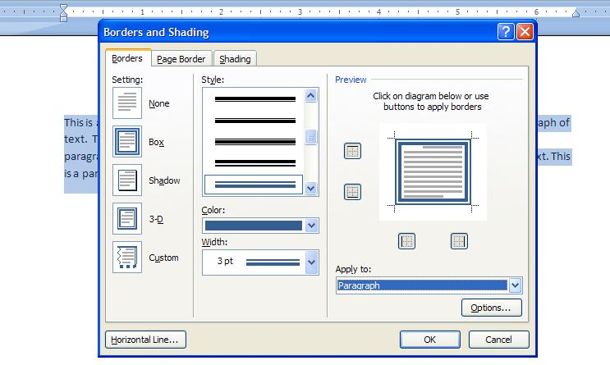

- Shading may also be applied to the paragraph/selected text by clicking the Shading tab and setting the options to whatever you wish. Click OK when finished.
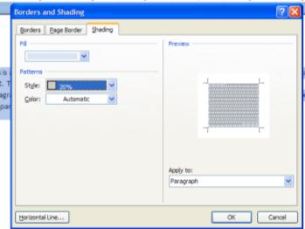

Adding Horizontal Lines
- Click the Insert tab, click the ClipArt icon in the Illustrations group. 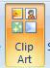

- In the “search for” box, key in Horizontal Lines and press Enter. Numerous types of lines should appear. Lines may be inserted at the insertion point by double-clicking the line you wish to add or clicking the down arrow and choosing Insert.
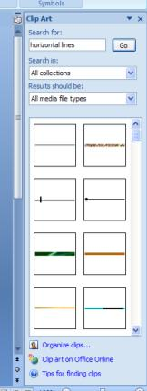

- These lines are clipart so they can sized up or down. Be sure to use the corner sizing handle to avoid skewing the image.

- Basic black lines may be inserted by pressing the hyphen or underline numerous times across the screen and pressing Enter.
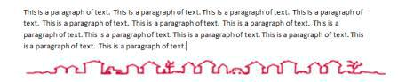
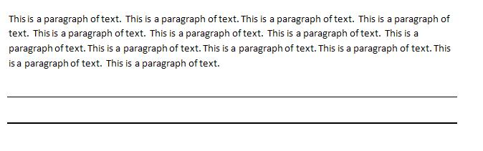

Inserting Header/Footer

- Click the Insert tab, click the down arrow below the Header or Footer icon in the Header & Footer group. 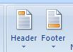

- Choose the layout which best suits your needs. There are numerous options for each.

Inserting Page Numbers
- Click the Insert tab; click the Page Number icon in the Header & Footer group. 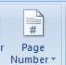

- There are numerous options for putting the page number at the top of the page or at the bottom of the page. Click on the one you want.
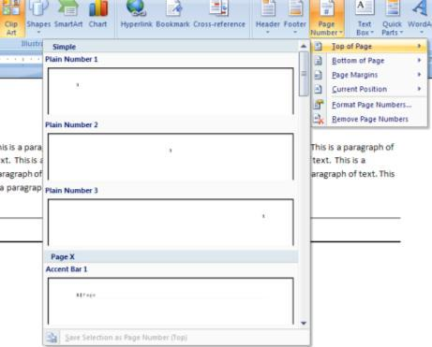

Inserting Symbols
- Click the Insert tab; click the down arrow below the Symbol icon in the Symbols group. 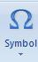

- Choose a symbol from the commonly used list, or click More Symbols to see more options. Many different types of picture icons/symbols are available in Webdings, Wingdings, Wingdings 2, Wingdings 3.
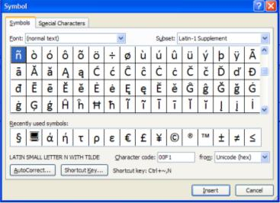

- Once you have found the symbol you want, double-click the symbol icon to insert it into your document or click on the symbol once and click the Insert button.

Inserting ClipArt/Images
- Click the Insert tab; click the ClipArt icon in the Illustrations group. 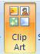

- In the “search for” box, key in words that describe what type of clipart you are looking for and press

Enter. Numerous images should appear. To insert a specific clipart, double-click the image you wish to add or click the down arrow and choose Insert. The images with the “world” icon in the corner are located on the Microsoft website. If you are not connected to the Internet, these will not show up.
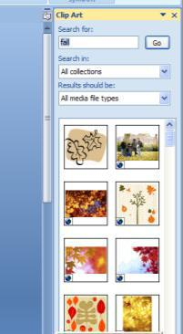
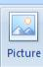
- To insert a saved image, click the Insert tab; click the Image icon in the Illustrations group. Find the picture in the list, then click the Insert button.
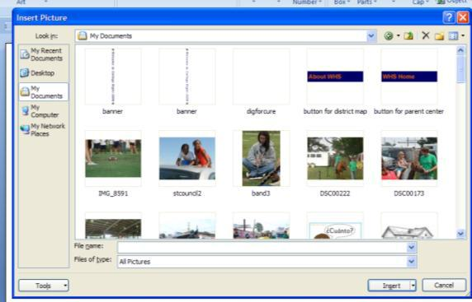

Using Picture Styles/Tools

- Click on the image in your document. If the Picture tools ribbon is not showing, click on the Picture Tools icon located on the Title bar. 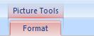

- Numerous options are available to enhance the appearance of the picture.

  - Brightness/Contrast/Recolor – alter the image by making it brighter, changing the contrast, and recoloring using various color options.

  - Compress Pictures – makes image smaller in saving size; helpful when you are sending a file with lots of pictures by e-mail.

  - Change Picture – allows you to change the picture without going back to Insert, Picture/ClipArt.

  - Reset Picture – sets the image back to its original setting.

  - Picture Styles – many options for displaying image; i.e., in a frame, alter shape, add a border, or add special effects such as beveled edges and shadows to it.

  - Arrange – changes the place image is put. Can put image in front/behind text, close to text, on a line by itself, align it to a specific spot on the page, etc. Can group objects together; can rotate image.

  - Size – can crop parts of the image out. Can set the height and width of the image.
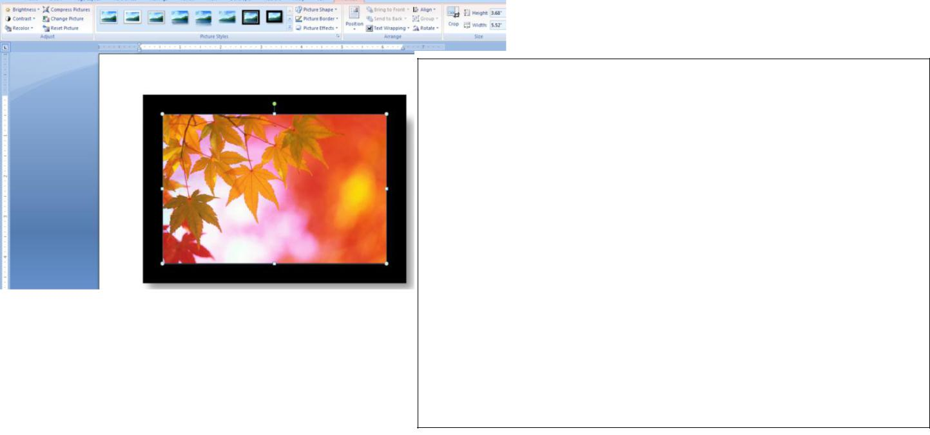

Creating and Inserting WordArt

- Click the Insert tab; click the WordArt icon in the Text group. 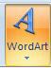 Click the WordArt design you wish to use. Type your text into the dialog box, choose the font and size you want, then click OK.
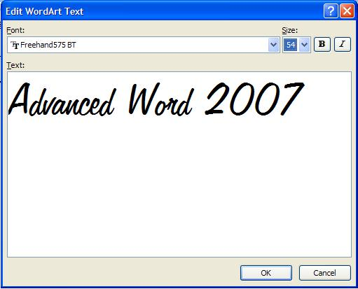
- Just as for images, there are many manipulation options available for WordArt; styles, fill, shadow effects, rotating options, size, etc.
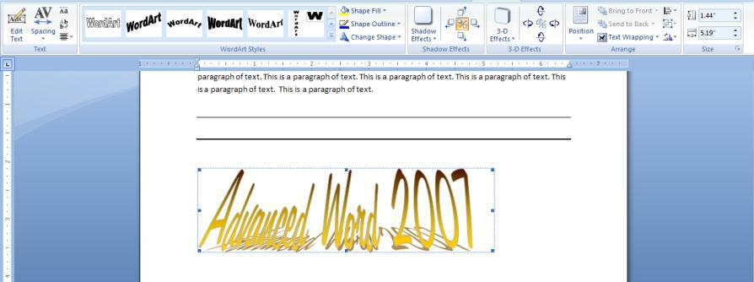

Inserting SmartArt

- Click the Insert tab; click the SmartArt icon in the Illustrations group. 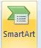 Click the SmartArt design you wish to use, then click OK.
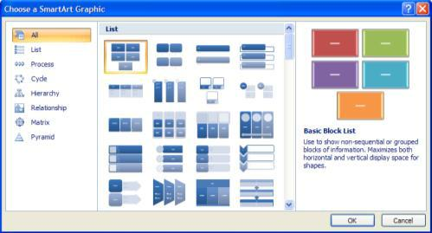

- Numerous options are available for manipulating the illustration. Click in each element to type text, add shapes, delete shapes, change the layout or style, etc.
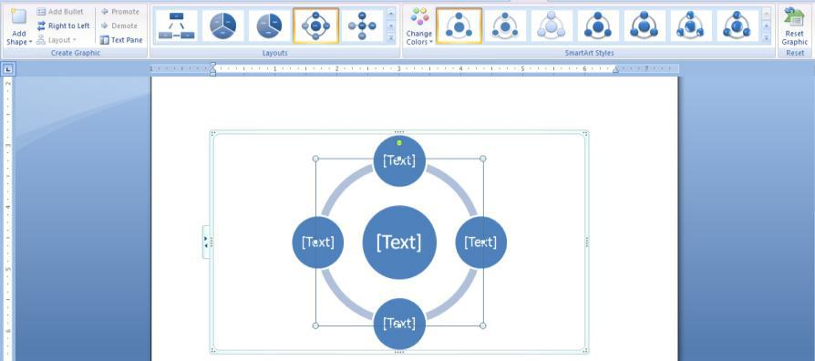

Adding Bullets/Numbering

- Click the Home tab; click the down arrow to the right of the bullets icon or the numbering
icon .

- Choose the style of bullet or numbering you wish to apply to text. Additional bullets are available by clicking on Define New Bullet at the bottom of the drop-down list. Click on Symbol or Picture to see additional items. Click OK once you have selected what you want.
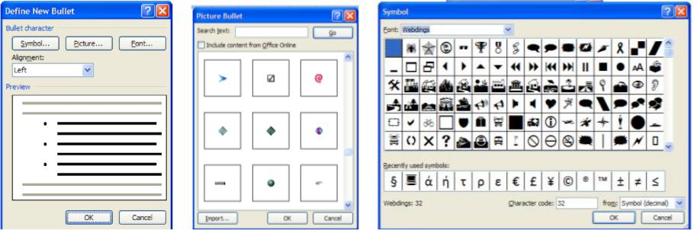

Picture Symbol

- Your own style of numbering can be set as well. Click on Define New Numbering Format and type in the style you want. Click OK when finished.
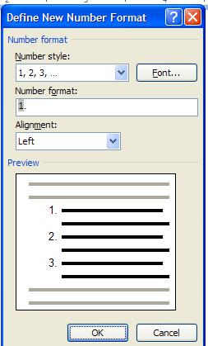

Adding References

Table of Contents
- Click the References tab, click the down arrow next to the Table of Contents icon 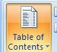.

- Choose the format you wish to insert into your document.
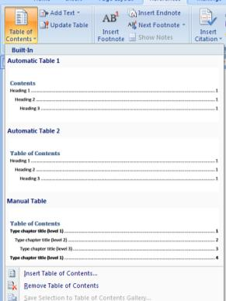

Footnotes/Endnotes
- Click the References tab. For a footnote, click the Insert Footnote icon 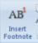. For an Endnote,

click the Insert Endnote icon 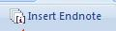.

- To insert another footnote or endnote, click on the Insert Footnote or Insert Endnote icon again.

- To move from one footnote or endnote to another, click the down arrow next to the Next Footnote icon and click the appropriate option.
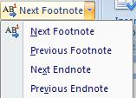

Citations & Bibliography

- Click the References tab. To insert a citation into your document, click the down arrow beside the Insert Citation icon and choose Add New Source
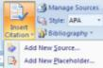.
- Fill out the information for the type of source it is, title, author, etc. The boxes listed are generally the required information. Additional fields can be shown by clicking in the Show All Bibliography Fields box.
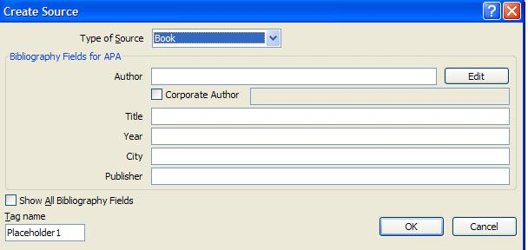

- If you need to edit the source at any time, click on the Manage Sources icon 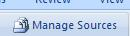.

- Choose the style of bibliography/citation you are creating by clicking on the down arrow to the right of the Style icon.

- Once finished with the sources, you can insert the bibliography/works cited page by clicking on the down arrow to the right of the Bibliography icon; click the format you wish to display the page in.
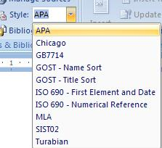
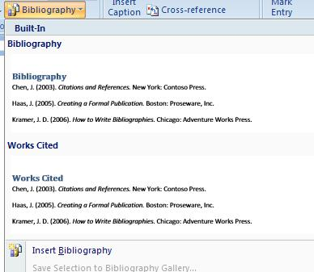

Use Hyperlinks
Use hyperlinks to point to web pages, other files, email addresses and other parts of the same document. Hyperlinks make it easy for the reader to access related content.
To follow a hyperlink in Word you need to hold down the Ctrl key and click with the mouse.
Insert a Hyperlink
- Select the text you want to use for the hyperlink
- Click the Insert tab on the Ribbon
- Click the Hyperlink button in the Links group
To a Web Page

- Click the Existing File or Web Page option in the Link to: panel
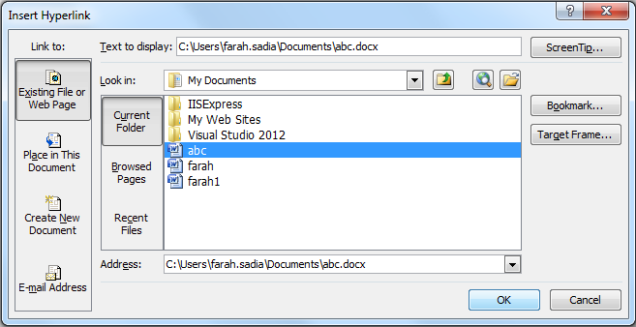
- Type the URL of the web page into the Address: box
or
Click the Browse the Web button, find the web page you want to use and close the browser
- Click Ok
To a File
- Click the Existing File or Web Page option in the Link to: pane
- Locate and select the file you want to link to
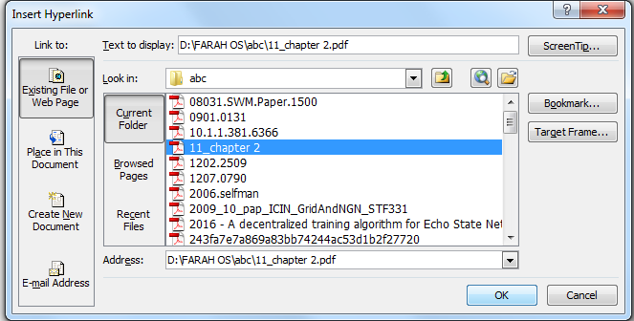
- Click Ok
To an Email Address
- Click the E-mail Address option in the Link to: panel
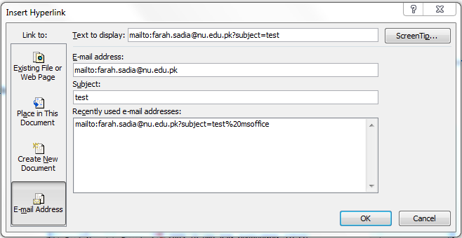
- Type the address you want to use
- Enter a subject for the email in the Subject: field for Word to enter a default subject on the email.
- Click Ok
Remove a Hyperlink
- Hyperlinks can be removed from text if they are no longer required.
- Right click on the hyperlinked text
- Select Remove Hyperlink from the shortcut menu

Working with Comments
Comments are used to add suggestions and reminders to a document for yourself and others. You can think of comments as a virtual Post-It note. They are displayed in a document within balloons.

Add a Comment
- Click in the document or select the text where you want the comment to be inserted
- Click the Review tab on the Ribbon
- Click the New Comment button in the Comments group
- Enter the text in the comment
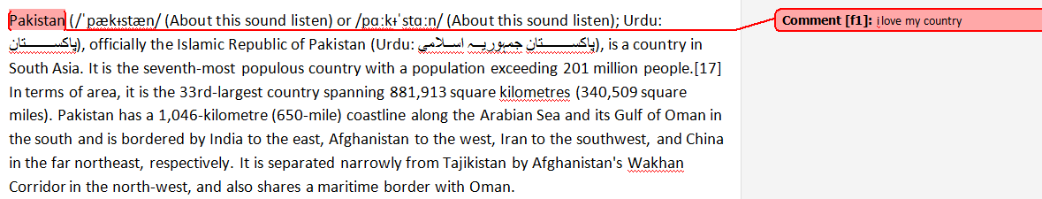
Delete a Comment
If a comment is no longer required it can be removed. To remove a comment you should delete it, not accept or reject the change like when using Track Changes.
- Select the comment you want to remove
- Click the Delete Comment button on the Review tab
Review Comments
- It is easy to jump to each comment within a document to review them.
- Click the Review tab on the Ribbon
- Click the Next Comment or Previous Comment buttons

Display or Hide Comments
Comments can be hidden to prevent them from becoming a distraction whilst working on other aspects of a document.
- Click the Show Markup button in the Tracking group
- Select Comments from the list to hide or display them
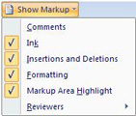

Use Macro
A macro is a series of actions that are recorded and can then be executed in a single click of a button. Create a macro to perform time consuming, repetitive tasks so that you don't have to complete them yourself.
When you record a macro, Word writes VBA code that performs the task. Creating a macro by recording the actions is easy to do, but has it's limitations. To edit your macros, or create more advanced and complex macros, you need some knowledge of VBA in Word.

Create a Macro
When you record a macro, Word records every step you take. It is recommended to write the required steps down on a piece of paper before recording.
A macro can only be edited by changing the VBA code. So if a mistake is made, it can be easier to delete the macro and then record it again.
- Click the View tab on the Ribbon
- Click the list arrow on the Macros button and select Record Macro
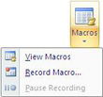
- Type a name for the macro in the Macro name: box
When entering the name of a macro, you cannot use spaces or start with a number
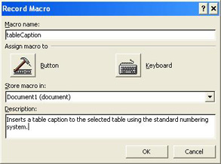

- Click the Store macro in: list box and choose to save the macro in one of the templates or in the current document
- Enter a description for the macro in the Description: field
- Click Ok
- Word starts recording your actions. A cassette icon is visible on the mouse arrow and the Stop Recording button appears on the Status Bar at the bottom of the window Perform the actions that you want the macro to record and click the Stop Recording button when you have finished

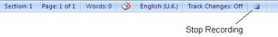
The macro has been created. It is not accessible by any toolbar button at the moment. The macro should be tested, and edited if required, before it is assigned a toolbar button.

Run and Edit a Macro
After creating a macro it should be tested to check that it functions as required. Sometimes a macro may not work as desired and the VBA code will require some tweaking.
Run a Macro
- Click the Macros button on the View tab or press Alt + F8 to open the Macros dialogue box
- Select the macro you want to run from the list
- Click Run
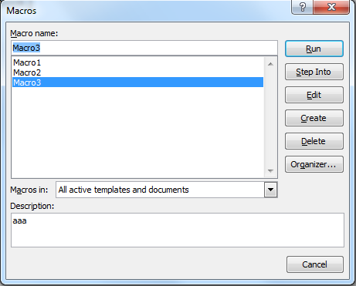

Edit a Macro
Editing a macro requires the use of VBA code. With just a little knowledge of VBA you can make minor adjustments to macros to correct them, or make them run more efficiently.
1. Click the Macros button on the View tab or press Alt + F8
2. Select the macro that you want to edit
3. Click Edit
4. The Visual Basic Editor displaying the code written for your macro. Delete or enter the necessary code
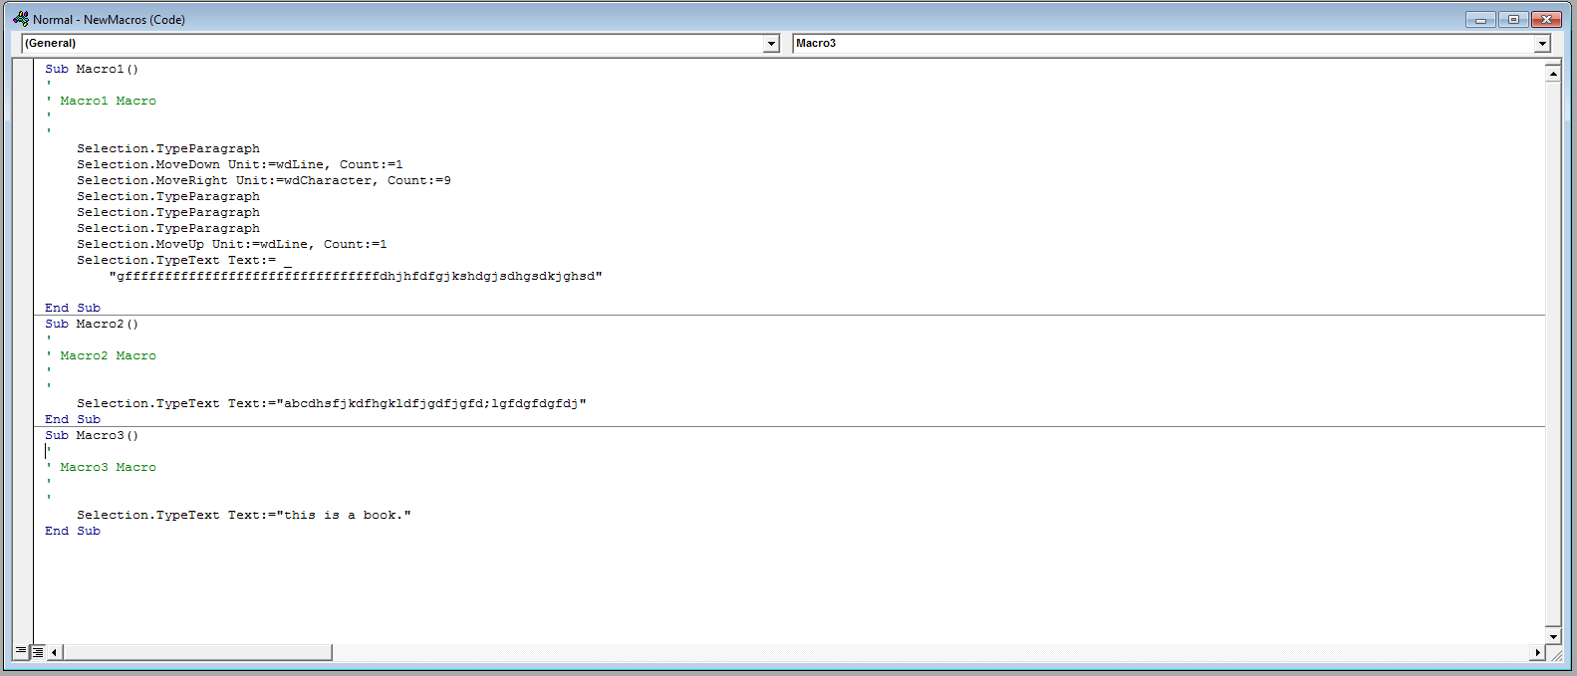
5. Click the Save button and close the VBE window

LAB ACTIVITY

Question 01:
Create a new document Write the following paragraph along with its equation. You will find the equation and symbols in INSERT tab.
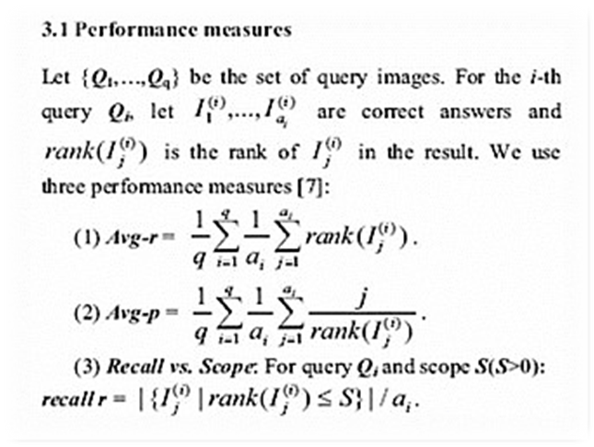
Question 02:

Create a file named lab1.docs containing the following text. With the specified changes.

- Font color for every noun should be blue and for verb it should be green.
- Text in bold should be made italic also.
- First paragraph should be in times new roman (10) and second should be in Arial (10).
- Nouns Saena and aerim should be in “Blackadder ITC” font size 36.
Note: There should be no green blue or red lines under the text.

Question 03:
Write an Article using sample template
  - Insert a 5 lines drop cap at a distance of 0.3cm from text
  - Insert header with your name and page no
  - Landscape orientated, size Tabloid, justified.
  - Insert citation, Bibliography and footnotes where necessary
  - Insert related picture or table with caption
  - Proof read your document and add comments

For drop cap, select the word or paragraph then go to insert then in the text group click on drop cap then select drop cap option.

Question 04:
Create a sales Table.
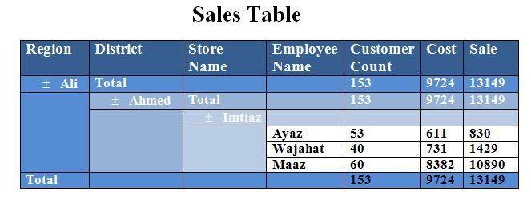
Question 05:
Create a document.
- Type the 3 Paragraphs of text and apply align left, align right, align justify.
- Assign bold, italic, underline for 3 Paragraphs, text background color different and give 3 different fonts for those.
- Write 4 different bookmark and use go to bookmark options.
- Apply auto formatting on text the word is Pakistan.
Question 06:
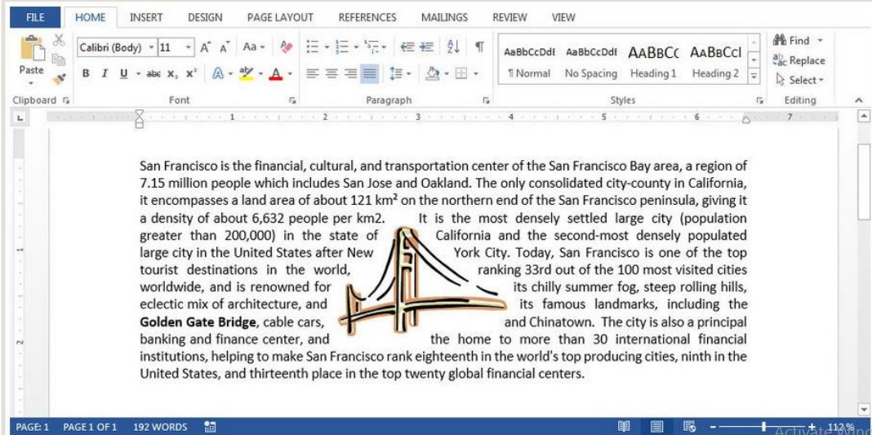
Create the document, add the picture and wrap the text.
Question 07:
Make a Student ID Card.

Question 8:
Design a bill for New Karachi Hospital using MS word. It should include the following information in the form of a table containing 6 rows and 3 columns. Row wise data given below.

